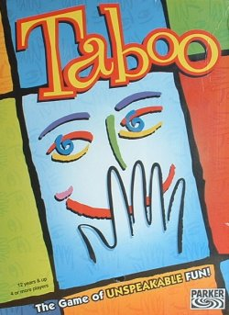

**-INSTRUCTIONS**

How to make the playing cards

Use a new blank playing card for each word. Write down a word on the top, underline it and then note down three others that would help to describe the one above. Everybody must create at least eight playing cards. Three of them must include vocabulary from topic 1 and 2. Mind your handwriting. In the end, mix all your self-made playing cards.

**school**

teacher

pupils

to learn

What you need

* your self-made playing cards
* a buzzer
* a timer/sand glass

How to play

**Divide the class in two teams.** Place the buzzer, the timer and cards.

**Choose one person from a team to be the first clue giver.** She/he comes to the front and takes a playing card. The card should be hidden from their team but visible to at least one of the opponents. That opponent should hold the buzzer. Another player from the opponent team holds the timer.

**Give verbal clues to your teammates to help them guess the word written at the top of the card.** Your clues can be sentences or single words. Do not use the words that are written on the taboo list on the card. The list on the card contains a number of words or terms that are considered "taboo," and therefore cannot be said aloud by the clue giver. The listed words, and any parts or forms of them, are forbidden as clues. For instance, you cannot say the words "baby" or "sitter" if the word "babysitter" is listed. You also cannot say "work" if one of the words listed is "work".

**Score one point for the clue giver's team for each word they guess correctly.** There is no penalty for wrong answers.

**Award one point to the clue giver's opponents for each time a taboo word is used, and for each time the clue giver passes on a word.**

**Hit the buzzer if you hear the clue giver use the Taboo word.** If this happens, the clue giver must move on to another word. The clue giver may continue giving clues until two minutes (the sand runs trough the sand glass twice!) expire. The team with the biggest number of words guessed wins.